Policy: | Behaviour
Applies to: | King’s High School Staff and Pupils
Authors: | Deputy Head Pastoral
Approved by: | KHS Committee, June 2016
Reviewed: | 1 July 2019; 1 July 2020
Signed: | S Watson, Deputy Head
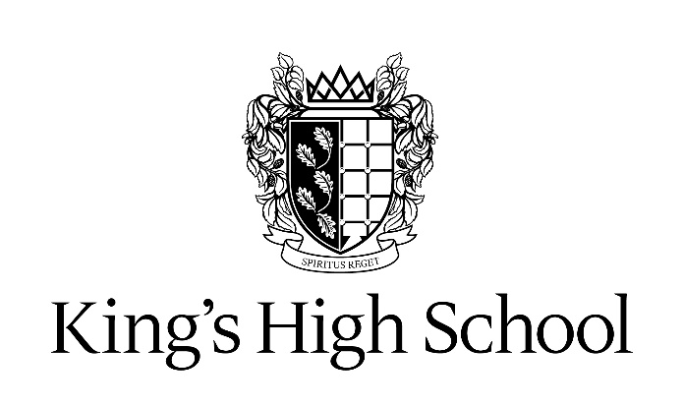

Behaviour Policy

Aims

This policy aims to:
- Provide a consistent approach to behaviour management
- Define what we consider to be unacceptable behaviour, including bullying
- Outline how pupils are expected to behave
- Trauma-informed and based on a ‘No blame, no shame’ approach
- Summarise the roles and responsibilities of different people in the school community with regards to behaviour management
- Outline our system of rewards and sanction
Legislation and statutory requirements
This policy follows the guidance set out by the Department for Education on:
- Behaviour and discipline in schools
- Searching, screening and confiscation at school
- The Equality Act 2010
- Use of reasonable force in schools
- Supporting pupils with medical conditions at school
It is also based on the special educational needs and disability (SEND) code of practice and Section 175 of the Education Act 2002, which outlines a school’s duty to safeguard and promote the welfare of its pupils
It should be read in conjunction with the Anti- Bullying policy, Policy for Discipline and Exclusions, Expulsion, Removal and Review, Policy for the use of Force to Restrain and Control, Searching and Confiscation Policy, Supervision Policy, Acceptable Use of ICT Policy and the Child Protection Safeguarding Policy.

Our approach

The aims of our school are clear that we wish both the individual and the community to thrive, and they tell us in themselves a great deal about the kind of behaviour we need from every member of the school if they are to be fulfilled.

We place relationships and young person’s sense of safety and security at the heart of classroom management and encourage nurture, warmth and empathy, even when a student is presenting with behaviours that feel challenging. The sense of community and belonging is all important and we take individual circumstances into account.

We believe we should show respect, kindness and consideration for others; we should cooperate and work together harmoniously, we should be thoughtful, responsible, helpful and appreciative in all we do.

How all members of the school community are expected to behave:

Pupil Code of Behaviour
We should:
- Consider the implications and effect of the way we act.
- Speak courteously and calmly to others, especially when we are feeling angry or upset.
- Listen attentively to others and not talk when they are.
- Speak well of others and not participate in gossip or rumour.
- Be punctual.
- Keep our word in respect of what we have agreed to do.
- Look out for others, their wellbeing, happiness and safety in all situations and at all times.
- Show our appreciation for what others do, saying thank you at every opportunity.
- Set an example by our own conduct, especially when we are in a position of leadership or have dealings with younger ones.
- Observe all the small everyday courtesies that make life pleasanter e.g. saying good morning, holding doors.
- Apologise graciously when need be and not bear any grudges.

Working in School Council meetings over the 2016-2017 academic year, Year 7 – 13 pupils and staff collaborated and drew up a code of conduct entitled “our School’s Aims and Pledges”. This was reviewed in 2018-2019 and a poster made for each classroom. An additional Code of Conduct was drawn up by a joint Sixth Form Committee in 2019-2020 when King’s and Warwick School moved to the shared Sixth Form Centre. (Appendix A)

Please see Appendix B for Covid-19 Behaviour Addendum outlining expectations during Covid-19 procedures as well as the Return to School documentation.

Our School Aims and Pledges

Aims

To foster a love of learning, intellectual curiosity, independence of thought and effective learning habits.
We will:
- Approach all lessons with open minds
- Take every opportunity to learn and go beyond the boundaries of the curriculum
- Be brave, take risks and be resilient in our learning
- Make the most of both independent and collaborative learning
To provide a safe, stimulating and supportive school environment, where each pupil can feel inspired, challenged and valued.

We will:
- Support all year groups by being friendly and inclusive
- Take advantage of all the facilities and look after them
- Be more motivated and willing to fill leadership roles
To foster a vibrant school community, built on trust and respect and instil a sense of social responsibility.

We will:
- Get involved in fundraising events and other volunteering opportunities
- Be inclusive and supportive of all people in the school community
- Be prepared to fulfil leadership roles
- Encourage the inclusion of the local community
To develop resilience and confidence and to inculcate integrity

We will:
- Be ourselves
- Always be honest
- Take risks and challenges
- Not to be afraid of failure
- Have confidence to speak up
To provide a rich and stimulating school experience, where our pupils can explore and develop their interests, gifts and talents and discover new ones.

We will:
- Take every opportunity offered
- Do things outside of our comfort zone
- Seek additional support when needed
- Volunteer to help in and out of school
- Put forward our ideas and get involved

Unacceptable behaviour
Misbehaviour is defined as:
- Disruption in lessons, in corridors between lessons, and at break and lunchtimes
- Non-completion of classwork or homework
- Poor attitude
- Incorrect uniform
Serious misbehaviour is defined as:
- Repeated breaches of the school rules
- Any form of bullying
- Sexual assault, which is any unwanted sexual behaviour that causes humiliation, pain, fear or intimidation
- Vandalism
- Theft
- Fighting
- Smoking and vaping
- Racist, sexist, homophobic or discriminatory behaviour
- Possession of any prohibited items. These are:
  - Knives or weapons
  - Alcohol
  - Illegal drugs
  - Stolen items
  - Tobacco and cigarette papers and vaping materials
  - Fireworks
  - Pornographic images
  - Any article a staff member reasonably suspects has been, or is likely to be, used to commit an offence, or to cause personal injury to, or damage to the property of, any person (including the pupil)
  - Misuse of mobile technologies

Bullying

Bullying is defined as the repetitive, intentional harming of one person or group by another person or group, where the relationship involves an imbalance of power.
Bullying is, therefore:
- Deliberately hurtful
- Repeated, often over a period of time
- Difficult to defend against

Bullying can include:

Type of bullying | Definition
Emotional | Being unfriendly, excluding, tormenting
Physical | Hitting, kicking, pushing, taking another’s belongings, any use of violence or aggressive behaviour.
Racial | Racial taunts, graffiti, gestures
Sexual | Explicit sexual remarks, display of sexual material, sexual gestures, unwanted physical attention, comments about sexual reputation or performance, or inappropriate touching
Direct or indirect verbal | Name-calling, sarcasm, spreading rumours, teasing, subtle comments and derogatory language
Cyber-bullying | Bullying that takes place online, such as through social networking sites, messaging apps, gaming sites or associated technology e.g. camera and video facilities
Peer Pressure | Pressure to conform. This can take many forms and can include (but is not limited to) bullying (including cyberbullying), sexual violence and sexual harassment, physical abuse such as hitting, kicking, shaking, biting, hair pulling, or otherwise causing physical harm; sexting and initiating/hazing type violence and rituals and upskirting. (Keeping Children Safe in Education September 2020).

Details of our school’s approach to preventing and addressing bullying are set out in our Anti-Bullying Policy.

Roles and responsibilities

It is the expectation that all pupils and staff within the school community will behave in accordance with this policy and the other related policies

Governors
Governors will review this behaviour policy in conjunction with the Head and monitor the policy’s effectiveness, holding the Head to account for its implementation.

Head
The Head is responsible for reviewing and approving this behaviour policy.
The Head will ensure that the school environment encourages positive behaviour and that staff deal effectively with poor behaviour and will monitor how staff implement this policy to ensure rewards and sanctions are applied consistently.

Staff
Staff are responsible for:
- Implementing the behaviour policy consistently
- Modelling positive behaviour
- Providing a personalised approach to the specific behavioural needs of particular pupils
- Reporting and recording behaviour incidents
The senior leadership team will support staff in responding to behaviour incidents.

Teachers (and all staff who have responsibility for pupils) have statutory authority to discipline pupils whose behaviour is unacceptable, who break the school rules or who fail to follow a reasonable instruction. Teachers can discipline pupils at any time the pupil is in school or elsewhere under the charge of a teacher, including on school visits and within the agreed policy.

Pupils
The expected code of behaviour is raised both formally (e.g. during form times, assemblies, PSHEE time), and informally and pupils are encouraged to respect each other and speak out if there are any issues. Pupil support systems are in place, where every pupil knows who they can go to for support.

Parents

We need and greatly value the support of our parents in upholding our Behaviour Policy. We particularly appreciate their support in these ways:

- Ensuring their child attends school regularly and punctually
- Ensuring their child has packed everything needed for the following day
- Ensuring they leave home each day wearing correct uniform with no jewellery or nail varnish (Years 7 – 11) or wearing appropriate school dress (Sixth Form)
- Ensuring they has a regular evening and weekend routine which to enable completion of homework to the expected standard and on time and without being interrupted by TV, phone, computers etc.
- Ensuring all equipment, possessions and uniform are clearly named and that valuables (eg iPods) are left at home
- Monitoring use of mobile phones and computers to ensure that potentially hurtful messages and chat to and about other pupils in the school are not being exchanged out of school hours
- Responding promptly to any message of concern from staff about their child’s behaviour in school and working with us to remedy any problems
- Signing the homework diary weekly (Key Stage 3)
- Alerting us to any personal issues or circumstances which might lead to poor behaviour or performance in school

Rewards and sanctions

The rewards and sanctions system is clearly outlined to all parents, pupils and staff in order to support good behaviour. All rewards and sanctions are listed on the pupil’s portal page and parents have immediate daily access (real time reporting) to this information.

Rewards
Pupils should always be encouraged to find satisfaction in conducting themselves well for its own sake. They do, however, respond well to a variety of rewards which are listed below:

- The personal satisfaction of knowing one has done well
- Verbal praise/encouragement/feedback
- Written praise/encouragement/feedback on work and in reports
- Rewards entered on iSAMS portal page
- Sixth Form: award of good grades in monitoring
- Prizes and awards
- Public congratulations in assembly
- Sent to receive congratulations privately from Head for a special achievement
- Postcards home for exceptional work
- Head’s commendations and recorded on Roll of Honour noticeboard
- Head’s meeting for achievement recognition

Sanctions

The school has always been proud not to have to impose a lot of sanctions. Those listed below should be used with discretion and fairness and always in the context of a clear explanation of what was wrong and what is positively required in the future.

- Verbal reminder / warning
- Parent made aware via a ‘note home’ being sent via the portal page
- Sent to more senior colleague for discussion and sanction as appropriate
- Move seat
- Move to another class
- Sent out to designated central place and seen by an SMT member
- Placed on report
- School-based community service or imposition of a task e.g. chewing gum, dining room, chair duty, litter, tidying of a classroom or other community activity
- Do or repeat work
- Do extra work or other appropriate written task in own time
- Remain after school to do work either as a one off or regular arrangement
- Contact / meeting with parents
- Withdrawal / removal of privilege of being taught in subject(s)
- Removal of other privilege e.g. going on a trip, internet access, free time at lunchtime, free afternoon
- Completing a reflection sheet
- Letter of apology
- Replacing damaged materials
- Confiscation
- Sent to lunchtime or after-school detention (teaching staff can put a pupil into lunchtime detention for subject concerns and only Heads of Key Stage/ Heads of Years and SMT can give a lunchtime or after school detention for disruptive or poor behaviour)
- Suspension – Head only
- Expulsion – Head only

Responsibility for pupils’ off-site conduct

Subject to the behaviour policy, teachers may discipline pupils for:

- misbehaviour when the pupil is:

- taking part in any school-organised or school-related activity or
- travelling to or from school or
- wearing school uniform or
- in some other way identifiable as a pupil at the school.

- or misbehaviour at any time, whether or not the conditions above apply, that:

- could have repercussions for the orderly running of the school or
- poses a threat to another pupil or member of the public or
- could adversely affect the reputation of the school.

Sanctions will only be imposed for the above only “to such an extent as is reasonable” and these sanctions can only occur on school premises or elsewhere when the pupil is under the lawful control of the member of staff.

The school keeps an electronic register of the rewards and sanctions imposed on the pupil’s portal page (and accessible to parents) and in additional, any records of conversation that are had with staff or parents about a pupil’s behaviour are kept on a student’s file. Where any serious sanctions are recorded, these are held with the Deputy Head (Pastoral) who has an overview of all misbehaviour in school and can identify where patterns may be and take actions to address these.

Malicious allegations

All members of the school community, pupils and staff are expected to behave accordingly to their code of behaviour and sanctions and disciplinary action will be taken as is reasonable and appropriate to the wrong doing. This may involve liaising with parents and other agencies and also for example disciplinary action against any pupil who is found to have made malicious accusations against staff.
Please refer to our Child Protection and Safeguarding Policy for more information on responding to allegations of abuse.

The Head will also consider the pastoral needs of staff accused of misconduct.

How the school encourages positive behaviour through teaching and learning

Positive behaviour and teaching and learning are inextricably linked. Effective teaching and learning can only take place in a well-ordered environment. Teachers establish clear and accepted routines. Students cannot learn and teachers cannot teach where there is disruption or lack of focus.

To unlock our pupils’ potential, teachers will:

- put relationships and a young person’s sense of safety and security at the heart of classroom management
- nurture students and show empathy, even when a student is presenting with behaviours that feel challenging
- consider a pupil’s individual circumstances
- ensure the classroom atmosphere is warmth and welcoming
- prepare well focussed and structured lessons so that the learning objectives are clear and relate to prior learning
- actively engage pupils of all ages in their learning
- develop learning skills systematically so that learning becomes increasingly independent
- use assessment for learning to reflect on what is known and set targets for the future
- have high expectations for effort and achievement
- motivate by well-paced teaching and a variety of activities matched to varying learning styles
- create an environment that promotes learning in a settled and purposeful atmosphere
- evaluate the effectiveness of teaching styles and methods

To unlock their potential, pupils will:

- complete their homework or any preparation required in advance of the lesson
- use independent learning resources such as the library
- give their lessons their full attention
- participate actively in all activities
- work collaboratively or independently as required by the teacher

In addition, there are a number of specific support systems in place to help students who misbehave. The form tutor, Head of Year and Head of Key Stage are the main academic and pastoral mentors for the pupil. They will work closely with the pupil, to talk through difficulties and put in place targets. For example, a report card may be used to support the student in focussing upon these targets during the school day. The Head of Year or Key Stage will meet the pupil on a regular basis for example every break time, to reflect upon progress with the targets. Also, senior pupils can act as pastoral mentors where appropriate. Subject workshops run by teachers and Sixth Form subject mentors, also are offered as additional support for students that may be struggling with the expectations

Pupil Support

The school recognises its legal duty under the Equality Act 2010 to prevent pupils with a protected characteristic from being at a disadvantage. Consequently, our approach to challenging behaviour may be differentiated to cater to the needs of the pupil.
Our Head of Learning Support and our Wellbeing Mentor will help to evaluate a pupil who exhibits challenging behaviour to determine whether they have any underlying needs that are not currently being met.
Where necessary, support and advice will also be sought from specialist teachers, an educational psychologist, medical practitioners and/or others, to identify or support specific needs.

Pupil Transition

We recognise that transition between primary and senior school as well as between Key Stage 3, 4 and 5, can prove difficult as pupils meet new expectations. We recognise this and ask teachers and form tutors to be particular mindful to immature behaviour that may occur naturally at such times and that therefore a degree of leniency in the application of sanctions may be appropriate: for instance, we do not send ‘notes home’ for our Year 7 pupils immediately. We also have dedicated Year 7 form tutors who are experienced in managing this transition year and understand the behavioural challenges that sometimes arise. In addition, students from other schools joining may have difficulty assimilating the culture of the school and may appear disrespectful. In such cases, staff are expected to employ tact while also making the expectations clear.

Pupil needs

When acute needs are identified in a pupil, we will liaise with external agencies and plan support programmes for that child. The Head of Learning Support works with parents to create the plan and review it on a regular basis.
We make a concerted effort to tailor the curriculum to the needs of each pupil and we make reasonable adjustments to the learning environment for those pupils with SEND such as modifying the curriculum and cocurricular timetables.

Training

Staff are provided with training on managing behaviour during-in service training days, after-school training sessions and attendance at external courses with a record of all training kept electronically by the Director of Innovation.

Links between the Behaviour Policy and other School Policies

We recognise that the behaviour policy is one of a suite of policies that is in place to safeguard our pupils and staff. We are required by national guidance to include the following policy reference links in our Behaviour Policy:

Links with the “Use of Force to Control or Restrain Pupils Policy”
It is the expectation that at King’s High we will never have to employ the procedures laid out in the policy: The Use of Force to Control or Restrain Pupils. However, all staff members have a responsibility to ensure that good order and discipline are maintained and the safety of pupils ensured and so will, if deemed absolutely necessary, (and acting in accordance with the policy), use reasonable force. This would only ever be as a protective measure and never in a disciplinary sense. The school does not, of course, use corporal punishment, nor does the school place any pupil in an isolation room for disruptive behaviour.
Links with the Anti-Bullying Policy
All schools are required to address antisocial behaviour within their school such as bullying, gang culture, racism, and any forms of extremism through their Behaviour and Anti-Bullying Policies. In addition, the behaviour policy and disciplinary action apply to pupils behaving antisocially beyond the school gate whether they are in the charge of a member of staff or not.

Links with the Searching and Confiscation Policy
Under no circumstance should pupils bring into school any prohibited items and the Head and staff authorised by them, have a statutory power to search pupils or their possessions including lockers and desks, without consent, where they have reasonable grounds for suspecting that the pupil may have a prohibited item.

Prohibited items are:
- knives or weapons
- alcohol
- illegal drugs
- stolen items
- tobacco and cigarette papers and vaping materials
- fireworks
- pornographic images
- any article that the member of staff reasonably suspects has been, or is likely to be, used
    - to commit an offence,
    - to cause personal injury to, or damage to the property of, any person (including the pupil)

The Head and authorised staff can also search for any item banned by the school rules which has been identified in the rules as an item which may be searched for. (Note: Weapons and knives and extreme or child pornography must always be handed over to the police. Otherwise, it is for the teacher to decide if and when to return a confiscated item.)

Links with the Child Protection and Safeguarding Policy

Monitoring Arrangements
The behaviour policy is publicised and made available to all parents, pupils (on the portal page) and staff yearly (beginning of September term at the latest) and is on the website.

Appendix A: Sixth Form Code of Conduct

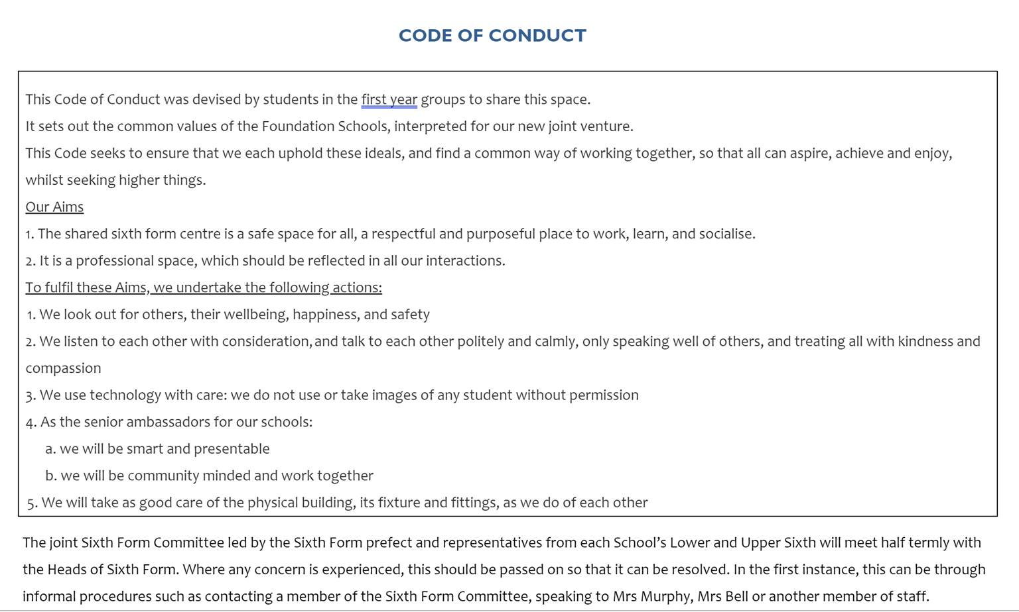

Appendix B: Behaviour policy: coronavirus addendum

This addendum applies until further notice.
It sets out changes and exceptions to our normal behaviour policy. Pupils, parents and staff should continue to follow our normal behaviour policy with respect to anything not covered in this addendum.
We may need to amend or add to this addendum as circumstances or official guidance changes. We will communicate any changes to staff, parents and pupils.

Expectations for pupils in school
New expectations
When pupils are in school, we expect them to follow all of the expectations set out below to keep themselves and the rest of the school community safe. These are based on the latest government guidance for full opening of schools.
Staff will be familiar with these expectations and make sure they are followed consistently.
Parents should also read the rules and ensure that their children follow the new procedures that have been put in place. Parents should contact the Deputy Head (Pastoral) if they think their daughter might not be able to comply with some or all of the rules, so we can consider alternative arrangements with them and support them to integrate back into school life.
Students should:
- Only use the allocated year group doors for arriving and leaving the school
- Follow hygiene instructions, such as handwashing and sanitising frequently and wiping down desks and chairs on arrival and departure from classrooms
- Only socialise with those in their bubble, following the expectations about mixing within bubbles at lunchtime and break and keep a social distance from anyone in another bubble.
- Move around the school following the oneway systems
- Follow the ‘catch it, bin it, kill it’ approach and guidance on sneezing, coughing, tissues and disposal and avoiding touching their mouth, nose and eyes with hands
- Tell an adult immediately if they are experiencing symptoms of coronavirus
- Use their own frequently required items such as pens and pencils
- Only use the designated zone for their year group in outdoor spaces and use this most frequently for socialising within their bubble.
- Use the designated toilets ensuring they only enter when there is space and washing hands thoroughly after using the toilet
- Take care to avaoid coughing or spitting towards another person

- Follow the more detailed procedures outlined in the ‘Return to School’ documentation
Rewards and sanctions for following rules
The full range of rewards remains operational and these may be used to encourage the new expectations to be followed.
However, if pupils fail to follow these rules, we will use the full range of usual sanctions including notes home and detentions.
Attendance and uniform
Expectations for attendance – the latest government guidance says attendance is mandatory from September. Students will be expected to register on time and in the normal way and parents should follow the usual procedures for informing the school of absence.
Expectations for uniform – from September 2020, all pupils (Y7-11) must wear uniform to school and follow normal school rules on uniform including correct skirt length and shoes and absence of make-up and jewellery.

Expectations for pupils at home
Remote learning
If pupils are not in school because they are required to isolate or in the event of a school closure, we expect them to:
- Email their HOY to say they are fit to work each day
- Attend live lessons unless there is a good reason not to
- Join these remote lessons with your microphone muted and camera off unless invited to contribute by your teacher
- Complete work to the deadline set by teachers
- Seek help if they need it, from teachers
- Alert teachers if they’re not able to complete work
- Use proper online conduct, such as using appropriate language in messages
- Use the school IT systems appropriately and safely in line with the Acceptable Use Policy (AUP) that should be signed at the start of the academic year by pupils and parents. A copy of the AUP can be found on the parent portal
- Make the most of the learning opportunities on offer including actively participating as much as possible
Dealing with problems
If there are any problems with pupils remote learning, including if they don’t engage with the remote learning set for them, we will: contact pupils and parents to try to resolve the issues.

Monitoring arrangements
We will review this policy regularly as guidance from the Department for Education is updated, and as a minimum

Links with other policies
This policy links to the following policies and procedures:
- Child protection policy
- Behaviour policy
- Health and safety policy

Lunchtime detentions are 35 minutes of a 1 hr 10 minutes lunch break and so always allow reasonable time for the pupil to eat, drink and use the toilet

